**DAILY ONLINE ACTIVITIES SUMMARY**

|  |  |  |  |  |  |  |  |
| --- | --- | --- | --- | --- | --- | --- | --- |
| **Date:** | **27/05/20** | | | | **Name:** | **Deena Muthappa** | |
| **Sem & Sec** | **8th sem, A sec** | | | | **USN:** | **4AL16CS028** | |
| **Online Test Summary** | | | | | | | |
| **Subject** | | **Iot** | | | | | |
| **Max. Marks** | | **30** | | **Score** | | **28** | |
| **Certification Course Summary** | | | | | | | |
| **Course** | **Introduction to Ethical Hacking** | | | | | | |
| **Certificate Provider** | | | **Great Learning** | **Duration** | | | **254 mins** |
| **Coding Challenges** | | | | | | | |
| **Problem Statement: 1) Program on Bubblesort**  **.** | | | | | | | |
| **Status: Completed** | | | | | | | |
| **Uploaded the report in Github** | | | | **Yes** | | | |
| **If yes Repository name** | | | | **deenamuthappa/Coding-Challenges** | | | |
| **Uploaded the report in slack** | | | | **Yes** | | | |

Online Test Details:

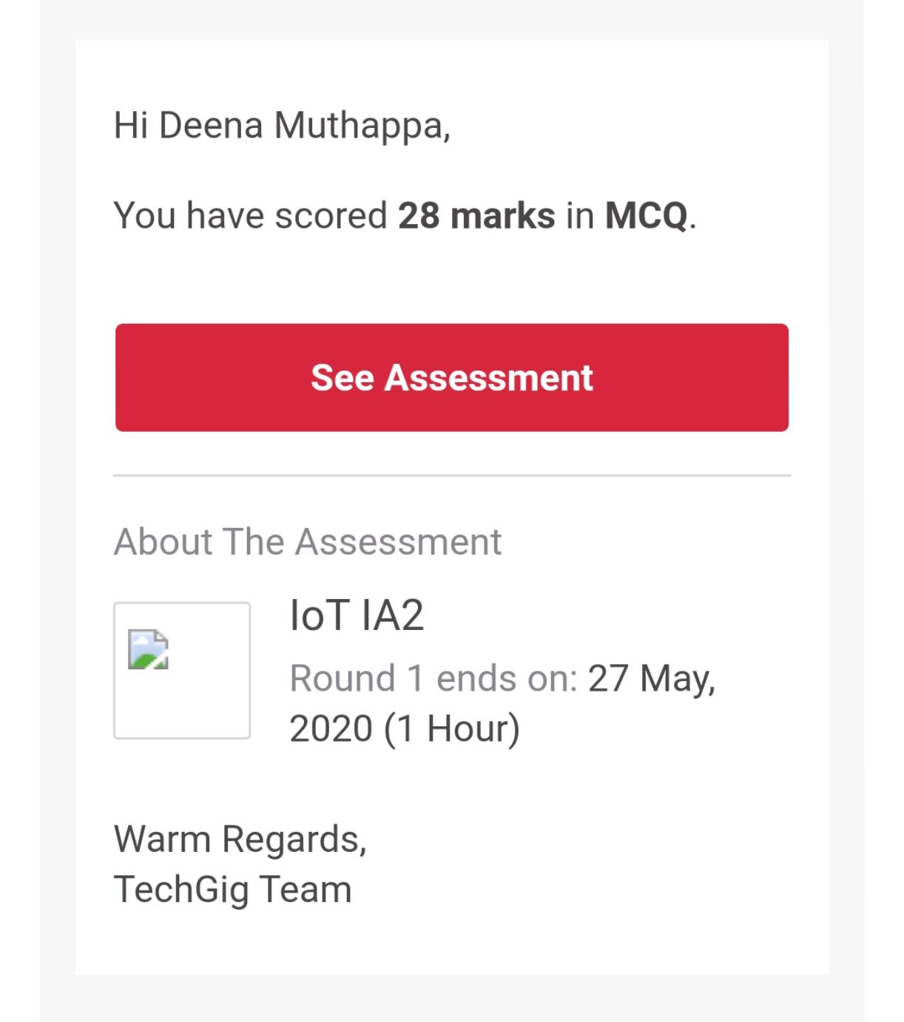

The test was on the subject Internet of Things.

Certification Course Details: **COMPLETED**

Coding Challenges Details:

#include <stdio.h>

#define MAXSIZE 10

void main()

{

int array[MAXSIZE];

int i, j, num, temp,c1=0,c2=0;

printf("Enter the value of num \n");

scanf("%d", &num);

printf("Enter the elements one by one \n");

for (i = 0; i < num; i++)

{

scanf("%d", &array[i]);

}

printf("Input array is \n");

for (i = 0; i < num; i++)

{

printf("%d\t", array[i]);

}

for (i = 0; i < num; i++)

{

for (j = 0; j < (num - i - 1); j++)

{

if (array[j] > array[j + 1])

{

temp = array[j];

array[j] = array[j + 1];

array[j + 1] = temp;

c1++;

}

else

c2++;

}

}

printf("\nSorted array is...\n");

for (i = 0; i < num; i++)

{

printf("%d\t", array[i]);

}

printf("\nTotal Number of passes is : %d\n",c1+c2);

printf("No of passes the values were swaped : %d\n",c1);

printf("No of passes the values were already sorted : %d\n",c2);

}